Getinge Ultrasonic Cleaner
Getinge Ultrasonic is a full range of high-quality, easy-to-use worktop ultrasonic cleaners that include practically every technical feature available. The models in the new series increase the ultrasonic effect further to achieve great results.
The reliable technology, in combination with the materials used, prolongs the service life of the units, while the design combines functionality with modern looks.
Key Features
- The range is available from 6 to 45 liters with lid and an optional basket available for all models
- Electronic time and temperature control & auto start temperature-controlled / temperature pre-selection
- High-performance transducer systems
- Sweep function, assuring a homogeneous sound field distribution with continuous shifting of the sound field maxima
- Degas function for highly efficient acceleration of the degassing process in the cleaning liquid, particularly in freshly mixed baths

TECHNICAL DATA

Measurements – Internal
Model | 60 | 100 | 150 | 180 | 300
Capacity (liters) | 6 | 10 | 14 | 18 | 28
Weight (kg) | 5.1 | 5.9 | 10 | 8.5 | 11
Size LxHxW (mm) | 365x186x264 | 365x278x264 | 568x340x224 | 390x340x321 | 568x340x321

PICTURES
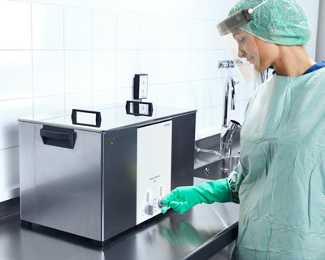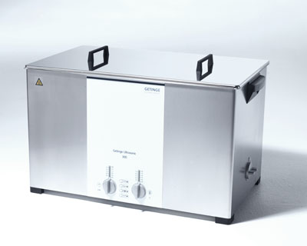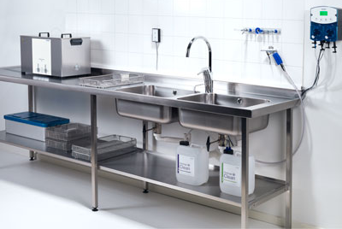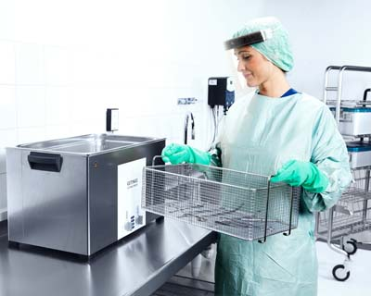
Getinge Ultrasonic Cleaner

